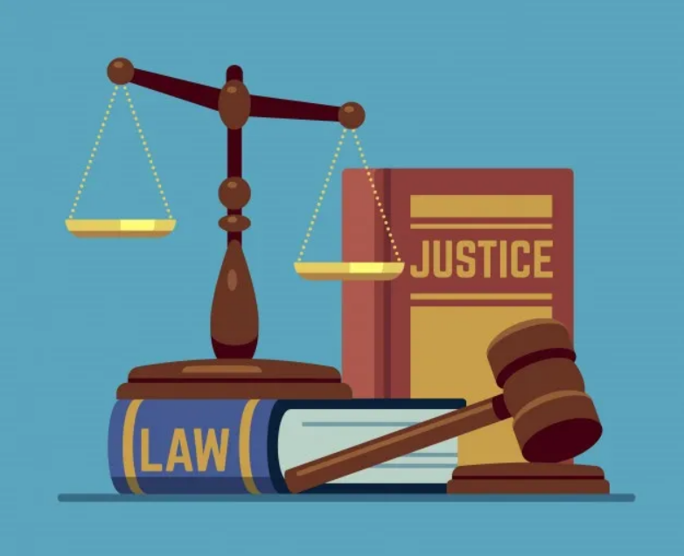
Students continue to build on their understanding of the concepts of the Westminster system, democracy and participation. They investigate the types of law in Australia and how they are made. They consider the responsibilities and freedoms of citizens, and how Australians can actively participate in their democracy. Students explore the different perspectives of Australian identity.

Term 2 Unit Outline – Civics and Citizenship

Year 8 HASS
2023

Year 8 Civics and Citizenship Term 2
Metacognitive Focus: Self Questioning (KWL Chart) |  |  | Instructional Strategy: Jigsaw
Week 1
Apply subject specific skills and concepts in familiar and new situations. (WAHASS74)
 | Lesson 1 | Lesson 2 |  | Lesson 3 | Lesson 4
Topic: | Introduction to Civics and Citizenship | Public Holiday |  | Key Concepts | Outline of Australian Government and Political System
Learning Intentions | Understand the meaning of civics and citizenship, and their importance in Australian society. |  |  | Understand and Explain the key concepts of civics and citizenship. | Understand the structure of the Australian Government and its key functions.
Success Criteria | Define the terms "civics" and "citizenship"  Identify at least three examples of how civics and citizenship are important in Australian society. |  |  | Define the key concepts of civics and citizenship, including democracy, government, rights and responsibilities, and Westminster System.  Identify examples of how each of these concepts are important in shaping Australian society and promoting civic engagement | Identify the three branches of the Australian government: the legislative, executive, and judicial branches.  Explain the roles and functions of each branch, including the role of the Parliament, Prime Minister etc.
Resources | BTN special Video and Document  https://www.youtube.com/watch?v=9A8_esPfOw8  KWL  Definitions  Whats being covered this term. |  |  | PPT and Guided Notes (LA Drive)  Jigsaw Activity. | Braindump.  WebQuest

Laws
Metacognitive Focus: Concept Mapping |  |  |  | Instructional Strategy: Role Play / Simulation
Week 2
The types of law in Australia, including criminal law, civil law and the place of Aboriginal and Torres Strait Islander customary law (ACHCK064)
 | Lesson 1 | Lesson 2 | Lesson 3 |  | Lesson 4
Topic | Outline of Australian Government and Political System | What are laws. Rules vs Laws | Civil vs Criminal Laws |  | Punishment and Sanctions
Learning Intentions | Understand the structure of the Australian Government and its key functions. | Differentiate between rules and laws and Understand their significance in society. | Differentiate between civil and criminal laws, and understand the different consequences for breaking them |  | Understand the punishments and consequences for breaking civil and criminal laws.
Success Criteria | Identify the three branches of the Australian government: the legislative, executive, and judicial branches.  Explain the roles and functions of each branch, including the role of the Parliament, Prime Minister etc. | Define the terms "rules" and "laws" and describe their differences.  Identify examples of rules and laws in their daily lives, in their school, and in wider society.  Explain the Rule of Law | Define the terms "civil law" and "criminal law" and describe their differences.  Identify examples of civil and criminal laws, and understand the types of disputes or offenses each one addresses. |  | Describe the different types of consequences for breaking civil and criminal laws, including fines, imprisonment, community service, and restitution.  Explain the factors that influence the severity of the punishment, such as the nature of the offense, the intent of the offender, and the impact on the victim or society.
Resources | Continue WebQuest Activity  Or democracy PPT  Or Types of Democracy WorkSheet | Yr 5 HASS lesson 1  Yar 4 lesson plans – mr stink  Understanding rules and laws.  Spot the rules and laws  Rules and laws sort | PPT and Notes (6.1)  PowerPoint and Guided Notes  WebQuest |  | Graphic Organiser  Punishments for Crimes  Intro to CIVIL handouts  Justice action study guide

Week 3
Metacognitive Focus: Graphic Organisers |  |  | Instructional Strategy: Case Studies
How laws are made in Australia through the courts (common law) (ACHCK063). How laws are made in Australia through parliaments (statutory law) (ACHCK063)
 | Lesson 1 | Lesson 2 |  | Lesson 3 |  | Lesson 4
Topic: | How Laws are Made | Statutory Law |  | Common Law |  | Catch up
Learning Intentions | Understand the process behind the making of laws in Australia. | Understand the concept of statutory laws and their significance in the Australian legal system. |  | Understand the concept of common law and its significance in the Australian legal system.
Success Criteria | Outline and Explain how laws are made in Australia  Identify two different types of Laws in Australia. | Define the term "statutory law" and explain how it differs from common law.  Identify examples of statutory laws, including federal and state legislation, and understand the process by which these laws are created and enforced. |  | Define the term "common law" and explain its origins in the English legal system.  Identify examples of common law, including precedents set by court decisions, and understand the process by which common law is created and enforced.
Resources | Law Making Yr 8 Inquiry Q  How Aus Laws are Made  Yr 6 lesson plans mr stink  Law and Crime Theme Pack  Wk 4 Making Laws | Statutory Law in Australia  Sources of Law  Precedent PPT  https://www1.curriculum.edu.au/ddunits/units/ls2fq2acts.htm |  | Common Law in Australia  Sources of Australian Law  Justice for All  Common Law vs Civil Law  Pair reading statutory vs common law | OJ simpson case Study https://peo.gov.au/teach-our-parliament/classroom-activities/parliamentary-processes-and-practices/make-a-law-house-of-representatives/

Australian Identity
Week 4
Metacognitive Focus: Mind Mapping |  |  | Instructional Strategy: Socratic Seminar
Different perspectives about Australia's national identity, including Aboriginal and Torres Strait Islander perspectives and what it means to be Australian (ACHCK066)
 | Lesson 1 | Lesson 2 |  | Lesson 3 | Lesson 4
Topic: | Revision | Test (Laws) Assessment 1 |  | Belonging and identity | National Identity - What does it mean to be Australian
Learning Intentions | Revise for assessments on Laws. |  |  | Understand the concepts of belonging and identity, and how they relate to citizenship in Australia. | Understand the concept of national identity and how it relates to citizenship in Australia.
Success Criteria | Explain each concept covered.  Define civil and criminal laws. |  |  | Define the terms "belonging" and "identity," and understand how they are related to one's sense of self and connection to others.  Identify the different factors that contribute to one's sense of belonging and identity, including culture, language, family, community, and experiences. | Define the term "national identity" and identify the different factors that contribute to it, including history, culture, language, symbols, and values.  Describe the ways in which national identity is shaped and expressed in Australia, including through national holidays, symbols, and ceremonies.
Resources | Laws Revision | On LA Drive |  | Understanding Identity PowerPoint  Privilege Walk Activty  Identity Project  Identity Iceberg | Australian culture and Identity  Aboriginal – National Identity  PowerPoint and Quiz Citizenship

Week 5
Metacognitive Focus: Visualisation |  |  | Instructional Strategy: Mindful Listening
Different perspectives about Australia's national identity, including Aboriginal and Torres Strait Islander perspectives and what it means to be Australian (ACHCK066)
 | Lesson 1 | Lesson 2 |  | Lesson 3 | Lesson 4
Topic: | National Identity (Values and Beliefs) | Australian Identity |  | National Identity – Multiculturalism | Source Analysis Practice
Learning Intentions | Understand the beliefs and values that contribute to national identity in Australia. | Understand the concept of Australian identity and its significance for national cohesion and citizenship. |  | Understand the concept of multiculturalism and its significance for national identity and citizenship in Australia. | Understand the concept of a Source Analysis and what is involved in the task.
Success Criteria | Identify the beliefs and values that are commonly associated with national identity in Australia, including the rule of law, democracy, freedom, equality, and multiculturalism.  Describe the historical and cultural factors that have shaped these beliefs and values, including the influence of Indigenous cultures | Define the term "Australian identity" and identify the different factors that contribute to it, including history, culture, language, symbols, and values.  Describe the ways in which Australian identity has evolved over time, including the influence of Indigenous cultures, British colonialism, and migration. |  | Define the term "multiculturalism" and describe its historical and cultural roots in Australia.  Identify the benefits and challenges of multiculturalism, including the promotion of diversity, the potential for social tension and conflict, and the impact on national identity. | Analyse sources of information to collect accurate statistics and infer meanings.
Resources | Continue Australian Cutlure and identiy Workbooj  Respecting beliefs and values | Continue Australian Culture and Identity Workbook  Australian Identity  Australian Culture Identity |  | http://www.start-at-zero.com/papers/multiculturalism/lessons.htm  http://www.multiculturalaustralia.edu.au/lessons/lessons.php  Multiculturalism and globalisation  A multicultural society | Source Analysis Skills  Stage 5 English

Direct Action
Week 6
Metacognitive Focus: Task Analysis |  |  | Instructional Strategy: Annotations (Text and Image)
The freedoms that enable active participation in Australia's democracy within the bounds of law, including freedom of speech, association, assembly, religion and movement (ACHCK061)
 | Lesson 1 | Lesson 2 |  | Lesson 3 | Lesson 4
Topic: | Source Analysis Practice | Source Analysis  Assessment 2 |  | Catchup | 5 Freedoms in Australian Democracy and Rights and Freedoms
Learning Intentions | Understand the concept of a Source Analysis and what is involved in the task. |  |  |  | Understand the five freedoms that are essential for democracy in Australia as well as the concept of rights and freedoms.
Success Criteria | Analyse sources of information to collect accurate statistics and infer meanings. |  |  |  | Identify and Define the five freedoms that are essential for democracy in Australia, including freedom of speech, freedom of religion, freedom of assembly, freedom of movement, and freedom of association.  Define the term rights and freedoms.
Resources | Practice Source Analysis task on LA drive. |  |  |  | WebQuest  Rights and Freedoms  Rights and Freedoms song analysis  Rights and freedoms take away

WEEK 7
Metacognitive Focus: Cornell Note taking |  |  | Instructional Strategy: Think Pair Share
The freedoms that enable active participation in Australia's democracy within the bounds of law, including freedom of speech, association, assembly, religion and movement (ACHCK061)
 | Lesson 1 | Lesson 2 |  | Lesson 3 | Lesson 4
Topic: | Public Holiday | SDD |  | Participating in Democracy – Understanding our rights and responsibilities – Civil Duties | Participating in Democracy – Legally exercising our rights and responsibilities Direct Action
Learning Intentions | Public Holiday |  |  | Understand the concept of civil duty and its significance for citizenship and democracy in Australia. | Understand the concept of direct action and its role in promoting democracy and social justice in Australia.
Success Criteria | Public Holiday |  |  | Define the term "civil duty" and identify the different forms of civic participation that are expected of citizens in Australia, including voting, following the law, paying taxes, serving on juries, and participating in community activities. | Define the term "direct action" and identify the different forms of direct action that have been used in Australia to promote social and political change, including protests, strikes, boycotts, and civil disobedience.  Describe the historical and cultural context in which direct action has been used in Australia, including the role of key events such as COVID vaccination protests, Climate Protests etc.
Resources | Public Holiday |  |  | Constitution Day  Anchor Charts  Reading Passage  https://peo.gov.au/teach-our-parliament/units-of-work/year-8/  Story of our rights | https://www.youtube.com/watch?v=BprIMX5yg-Y  https://www.youtube.com/watch?v=PEeTl7rgjGo

Week 8
Metacognitive Focus: Guided Notes |  |  | Instructional Strategy: Inquiry Based Learning
Notes: Book Computers for Assessment 3 & Report Data Due
How citizens can participate in Australia's democracy, including use of the electoral system, contact with their elected representatives, use of lobby groups and direct action (ACHCK062)
 | Lesson 1 | Lesson 2 |  | Lesson 3 | Lesson 4
Topic: | Examples of Direct Action | Research (Assessment 3) |  | Research (Assessment 3) | Research (Assessment 3)
Learning Intentions | Understand the concept of direct action and its role in promoting democracy and social justice in Australia.
Success Criteria | Define the term "direct action" and identify the different forms of direct action that have been used in Australia to promote social and political change, including protests, strikes, boycotts, and civil disobedience.  Describe the historical and cultural context in which direct action has been used in Australia, including the role of key events such as COVID vaccination protests, Climate Protests etc.
Resources |  | BOOK COMPUTERS |  | BOOK COMPUTERS | BOOK COMPUTERS

Week 9
Metacognitive Focus: Elaboration |  |  | Instructional Strategy: SWOT Analysis
Notes: Book Computers for Assessment 3
How citizens can participate in Australia's democracy, including use of the electoral system, contact with their elected representatives, use of lobby groups and direct action (ACHCK062)
 | Lesson 1 | Lesson 2 |  | Lesson 3 | Lesson 4
Topic: | Research (Assessment 3) | Research (Assessment 3) |  | Research (Assessment 3) | Validation
Learning Intentions
Success Criteria
Resources | BOOK COMPUTERS | BOOK COMPUTERS |  | BOOK COMPUTERS | Assessment 3 (Parts A and B due)

Week 10
Metacognitive Focus: Reflection (PMI Chart) |  |  | Instructional Strategy: Simulations / Games
Notes: Ellie Away at Country Week
How citizens can participate in Australia's democracy, including use of the electoral system, contact with their elected representatives, use of lobby groups and direct action (ACHCK062)
 | Lesson 1 | Lesson 2 |  | Lesson 3 | Lesson 4
Topic: | Shark Cull Documentary and notes and Questions |  |  | One Punch video and questions | WebQuest
Learning Intentions | Explore the Shark Cull direct action in Western Australia. |  |  | Explore one punch laws. | Understand direct action and its uses in the past
Success Criteria | Identify examples of direct action within the documentary. |  |  | Define if the action was a civil or criminal suit.  Evaluate and Explain if students agree or disagree with the verdict. | Complete a WebQuest to find information on a source.
Resources | Shark Cull Documentary  Shark Cull Note Taking Template  Validation Questions |  |  | One Punch Video  One Punch Note taking and Questions | WebQuest (Direct Action)  Book Computers

